Buckling of a thin walled beam

Run the analysis

The macros in this folder simulate the nonlinear process of calculating the buckling of a shell-based beam.

The fundamental steps of simulating the buckling are the following:

* **Preload the beam**, this way ansys computes the geometric stiffness matrix.
* **Obtain the modes**, this is a simple linear problem of obtaining the eigenvectors and eigenvalues.
* **Deform the beam with the shape of one of the eigenmodes** and a factor f, a good value of maximum imperfection is L/200 (where L is the length of the beam), so if the eigenmode has a maximum displacement (dmx) of x, the factor f = L/(200*x).
* Finally, **solve the nonlinear problem** of compressing the imperfect beam.

First, open Ansys, make sure that the **Ansys** directory is the same directory where the macros are stored (file>change directory).

You can also change the jobname (file>change the jobname). If you are going to **simulate different modes of the same beam, or different imperfections** you will **have to save the file after obtaining the modes**, and **change the name of the filename when you proceed to solve the nonlinear step**. Otherwise, you will overwrite the results of the modal simulation with the nonlinear step, so when you predeform your beam, you will not be predeforming with the modal shape.

Now, **write in the command line *main****.* This will run the macros, geom, mesh, boundary, and Slinear.

After this observe the modes, **General Postproc>read results>first set** and write in the **command line** *pldisp.* This will give you the mode shape of the first mode. You can see other modes by clicking **General Postproc>read results>next set** and writing *pldisp*. **Write down the maximum deformation (DMX)** of the mode shape you will use to model the nonlinear problem (usually the first mode).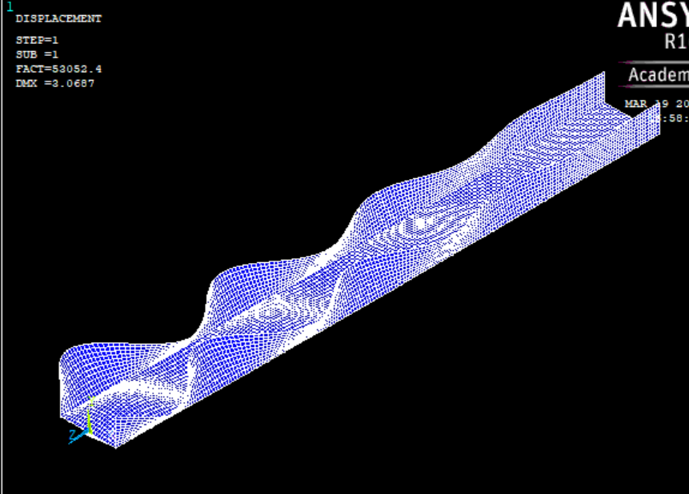

*Caption of the deformed shape of a beam*

**Save as jobname.db** (file>save as jobname.db), and **change the filename** (file>change jobname..) let’s name it file2.

**Run nonlinear analysis**, by writing *nonlinear* in the command line. **Compute f as imperfection/DMX**, imperfection is usually in the order of hundredths of the length.

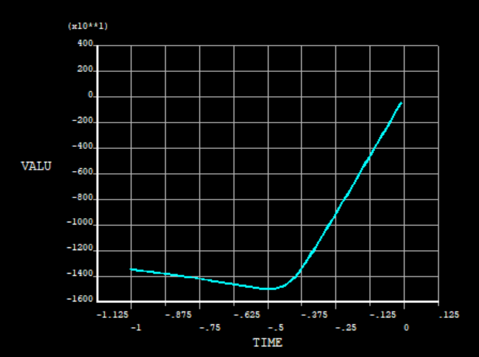

*Caption of the force-displacement results of the nonlinear analysis*

The plot at the end is the force-displacement curve. You can extract the buckling force as the maximum force.

Observation: I ran the analysis using a length of 200mm; thickness of 1mm; Young’s modulus E=210 GPa, imperfection of 3 mm (quite big); and a material that has a bilinear plasticity that yields at 500 MPa, with a slope of 2.1 GPa. The Buckling load obtained in the linear analysis is 53,000 N, while the load obtained in the nonlinear analysis is 15,000 N, a lot smaller.

Explanation of each macro

Geom

Generates the geometry. Important commands:

* k,1,-10,10,0 -> creates keypoint 1 at the location x=-10, y=10, z=0
* l,1,2 -> creates line from keypoint 1 to keypoint 2
* *ask,L,length,200 -> prompts a window to ask the user “length”, stores the value in a variable “L”, if user presses enter without filling any value the default length will be 200.
* adrag,1,2,3,,,,4 -> extrudes lines 1, 2 and 3 following the path of line 4.

Mesh

Creates the mesh. Important commands:

* et,1,181 -> creates element type 1 as shell181
* sectype,1,shell -> creates a section for the shell
* secdata,t -> assigns thickness t to the section
* mp,ex,1,2.1e5 -> material properties for materials 1. E = 2.1e5, i.e. Young’s modulus equals 210 GPa.
* mp,nuxy,1,0.3 -> Poisson ration equals 0.3.
* aatt,1,,1,,1 -> assigns material 1, element type 1, and section type 1 to the unmeshed areas.
* esize,le -> assigns element size le
* amesh,all ->meshes all the areas

Boundary

Creates the boundary conditions. Important commands:

* nsel,s,loc,z,-L ->select all the nodes located at z=-L
* d,all,uz ->fixes displacements in z directions for all the selected nodes
* allsel -> select all nodes again
* nsel,s,loc,z,0 ->select all the nodes located at z=0
* cp,1,uz,all -> couples the displacements in z in all selected nodes, i.e. all selected nodes will have the same displacement in z
* *get,nt,node,0,num,min -> Of all selected nodes, get the smallest node number and store this value in the variable “nt”.
* f,nt,fz,-1 -> apply a force of value -1, in z direction, at the node “nt”.

Slinear

Eigenmode extraction. Important commands:

* antype,static -> solve static
* pstress,on -> use the results to compute the geometric stiffness matrix
* antype,buckle -> assign buckling solver
* bucopt,subs,modess -> use subspace method to cumpute the modes, extract “modes” number of modes

nonlinear

Nonlinear analysis. Important commands:

* upgeom,f,1,modenum,file,rst -> update the geometry using the shape of the mode “modenum” in the file “file.rst”, with a scaling factor “f”.
* fdele,all,all -> delete applied forces.
* d,nt,uz,-di -> apply displacement in z direction of -“di”, at the node “nt”
* tb,biso,1,1 -> Define bilinear isotropic hardening for material 1 at temperature 1
* tbtemp,0 -> defines temperature value
* tbdata,1,fy,2100 -> assigns to material 1 a tangent modulus of 2100 MPa at yield stress of “fy
* nlgeom,on -> activate nonlinear geometry
* nropt,full -> use full Newton Raphson
* neqit,100 -> assign maximum number of equilibrium iterations for each substep
* nsubst,80,200,50 -> assign initial number of substeps, maximum number of substeps, minimum number of substeps
* outres,all,all -> store all results of all substeps